|  |  |  |
| --- | --- | --- |
| O*peration  Romania  Trust* |  | News Update **JUNE 2022** |

Showing God’s love to the people of Romania by supporting families in and around Oradea

Reg. charity No. 1053406 Registered address: 38 Meadow Way Littlehampton, West Sussex. BN17 6BL. United Kingdom

Where does the time go? We are already a third of the way through May. Children will be looking forward to half term, young people will be looking forward to exams to determine what is next in their journey. Families may be looking forward to the summer holidays when, following the lifting of Covid restrictions, they will be able to go away. You may be looking forward to other things.

What about the people of Romania – what are they looking forward to? As the two testimonies tell us, they look forward to the help we are able to give them through your kindness in sponsoring them.

Patients in the care of the Hospice are grateful for the care they receive from the Hospice Team and that’s why we are supporting them through the Coffee Morning on Saturday 11th June. Come and join us, if you can. If not, would you be able to send a donation to our Treasurer to add to the money collected at the Coffee Morning? God bless you all and thank you.

**Roger Purdom**

**Hospice Care in Romania**

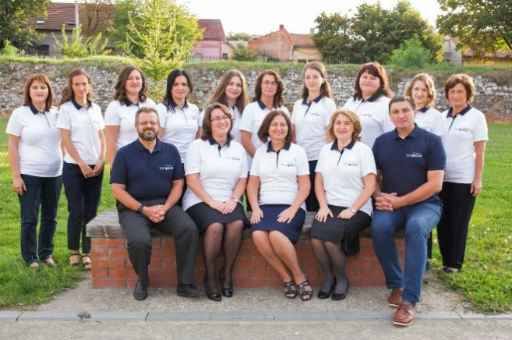In 2005 ‘Hospice Emanuel’ a home palliative care centre was set up to provide much needed help and support for those suffering from terminal cancer for adults and children.

Over 2,300 adult patients with advanced cancer and 250 children with life-threatening diseases have, so far, benefited from free **home palliative** **care services**, conducted by specialists.

In 2016 Hospice Emanuel obtained the ‘Accreditation Certificate for Excellency’ in provision of palliative care with the highest score nationwide for palliative care services given at home.

Here is the staff team – Doctors, Nurses, Therapists, Social Workers, Chaplain, Administrators.



**Coffee at Parkside**

Because of the rise in Covid infections, we postponed the coffee morning at Parkside Church St Floras Road, Littlehampton, to Saturday 11 June. We would still love to see you for coffee, chat, and a chance to stock up on books, cakes and plants. Money raised will support **The Emanuel** **Hospice in Oradea** mentioned above**.**  Doors open at **10 am**. Contributions of books cakes and plants would be welcome. See you then?

For more details about the care the Hospice provides, search for “Emanuel Hospice Oradea” and select the English version.

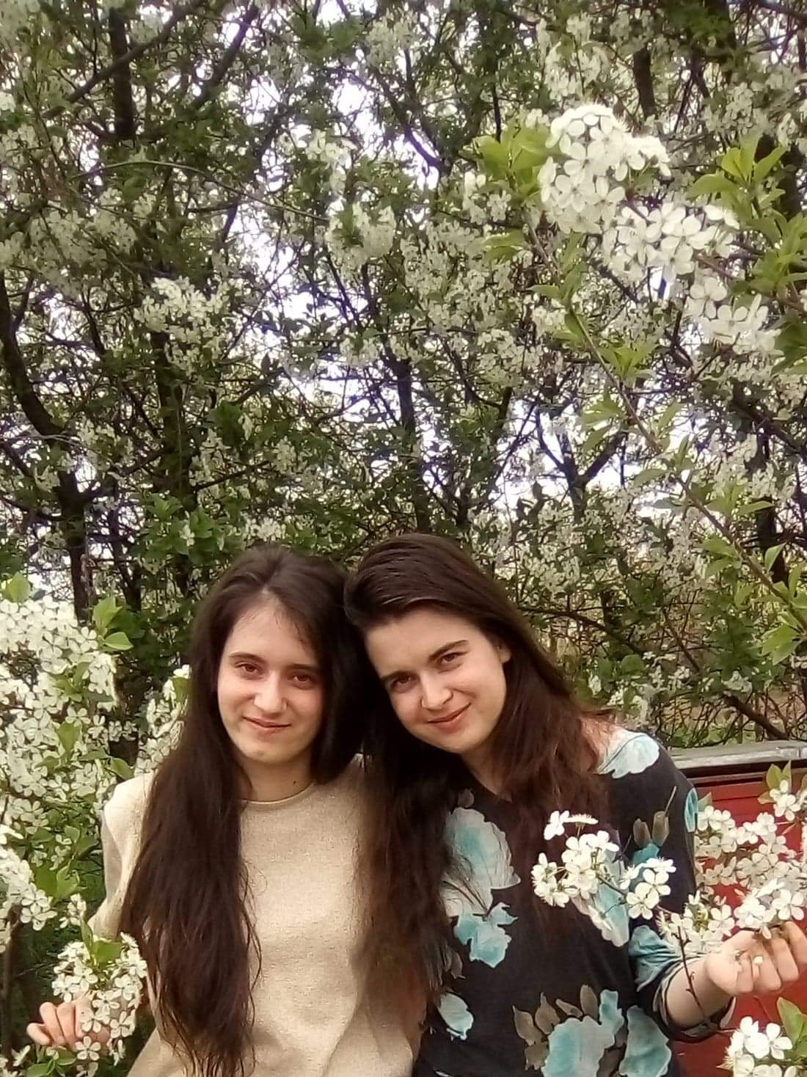**Thank you**

Today I am writing to you because I want to say thank you and show my gratitude for everything you do for myself and my family.

**My name is Delia Csoka**. I never thought God would work so well in my life or that He prepared something good for my life. I started high school without much courage because I knew the situation in my family: my mother has been ill for many years after my brother was born; and my father was retired. It was harder for my parents at that time because we had to spent some of money for medicines every month and we were three children in family: Darius, Flavia and me.

**Flavia and Delia**

But if God has a plan with you. He will not leave you alone and He will hold your future.

Thank you from the bottom of my heart for your help that made me move forward. Today I'm in the first year as a student in general medicine in Oradea and I want to be able to help those around me. I am aware that the only thing that remains after us as human, is the good we have done.

Thank you for everything, I embrace you! Be blessed by God!

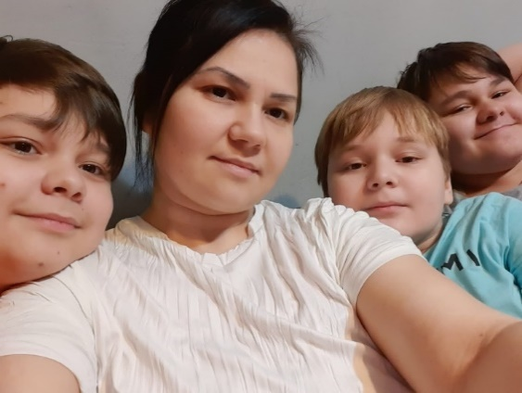**You Carry Us in Your Prayers**

Hi, I am Alina and I am a mother of three boys. My husband is gone most of the time, and for no reason, because he rarely sends me money, he is not a help for me and my family and that's always been the case.

And that is why I like to express to you all my appreciation for the material help, but not least because **you carry us in your prayers**. This means very much for me. I think often of you and of your great deeds because this help is always welcome. Every time I am looking forward for the day when I receive it.

I thank God for all of you that are involved in this great work. May He reward you as only He knows and can. God bless you!

Love, Alina Faur.

Thank you for your prayers and support.

You can **unsubscribe** from receiving the Prayer Update or any other information we might want to send to you by contacting our Chairman, Roger Purdom at [roger.purdom@btinternet.com](mailto:roger.purdom@btinternet.com)

*OPERATION ROMANIA TRUST Treasurer & Sponsorship Co-ordinator, Miss Margaret Wilkinson, 2 Knightscroft Avenue, Rustington, West Sussex BN16 2HN Phone: 01903 775927 Email:* [*mawatsea@outlook*](mailto:mawatsea@outlook)*.com*

*Trustees: Roger Purdom (Chair); Andrew Terrell; Margaret Wilkinson; David & Margaret Millidge; Colin Beckhurst; Keith Varney.*